WORKSHOP #10 - PAINT ESTIMATOR

## APS145NFF - Group 2 Members:

* Nasita - Logic 1 - Pseudocode
* Joshua Civello - Logic 1 - Flowchart
* Seulgi Lee - Logic 2 - Pseudocode
* Md Ridwan Hossain - Logic 2 - Flowchart
* Luca Novello - Logic 3 - Flowchart/Pseudocode

## Workshop Overview

**Online webpage calculator application** tools are very popular – especially when you need an estimate when ordering products/services that have a heavy price tag attached. One example of such a product is paint. Performing an accurate cost estimate can get complicated and have many steps involved. Most customers will not dedicate too much time in doing this accurately themselves and will most likely make errors.

## Workshop Details

An online paint estimator tool is required to provide an accurate estimate of the number of cans of paint needed for the customer’s needs as well as the total cost (subtotal: without tax and gross: with tax). You need to define the overall processes required for this application. There are some basic requirements you need to account for:

1. Paint TypesBase Paint
   * Base coat paints have less coverage as they are designed to soak into the wall/surface material and seal the pores so a smooth and consistent final coat can be applied for a better professional look.
   * Typically, two (2) coats are applied for best results, but this ultimately is up to the customer if it is even used at all
   * Base coat paints have a coverage of 11 and cost $46.25 per can

Finishing Paint

* + Finishing paints are more expensive and provide the final desired color (they also have higher coverage rates if a base coat was used)
  + Depending on if a base coat paint was applied (and how many coats), the number of suggested coats required of the finishing paint varies:
    - If two (2) coats of base paint were used, one (1) coat of finishing paint is sufficient
    - If one (1) coat of base paint was used, two (2) coats of finishing paint is suggested
    - If no base paint was used, three (3) coats of finishing paint is suggested
    - The number of planned coats is ultimately up to the customer
  + Finishing paints have a coverage of 16 and cost $54.50 per can

1. Input Information
   * You need to be able to determine the overall area that needs painting to be able to provide an estimate.
   * You can’t ask the customer to simply enter the total area – the online tool must determine and calculate this information based on the necessary inputs from the customer
   * You must provision for the customer to enter the required dimensions/measurements that reflect their painting requirements (and this can mean multiple rooms!)
   * You can assume metric meter (m) units are used.

Note/Hints

* You should not include openings that don’t require painting such as doors and windows
* Don’t forget about ceilings…

1. **Output Information**
   * The final output to the customer should include the following details:
     + Total area to be painted
     + Itemized listing of the paint, unit cost/can, quantities, and total cost. This means…
       - Base paint (if applicable) will be on its own line (showing the unit cost per can, number of cans required and the total cost for that paint before taxes)
       - Finishing paint will be on its own line (showing the unit cost per can, number of cans required and the total cost for that paint before taxes)
     + **Subtotal** of the detailed itemized total above before taxes
     + **Taxes (HST)** amount to be applied to the sub-total amount at a rate of 13%
     + **Total** of the subtotal and taxes combined

# DATA STRUCTURES

| Base_Paint/Finishing_Paint | |
| --- | --- |
| **type** | *returns “****base****” or “****finishing****”;* ***\*required*** |
| **coverage** | *returns* ***11 for “base”*** *or* ***16 for “finishing”****; in* |
| **cost** | *returns* ***46.25 for “base”*** *or* ***54.5 for “finishing”****;* ***per can*** |
| **taxRate** | *returns tax rate for the item;* ***currently 0.13 (13%)*** |
| Wall/Opening (Ceiling included as Wall) | |
| **width** | ***width*** *of wall/ceiling,opening; in* |
| **length** | ***length*** *of wall/ceiling,opening; in* |
| **area** | ***length * width*** *of wall/ceiling,opening; in* |
| Room | |
| **walls** | *An* ***array*** *of* ***Wall*** *objects* |
| **openings** | *An* ***array*** *of* ***Opening*** *(door/window****)*** *objects* |
| **totalArea** | *The* ***sum of all*****walls** *object areas* ***minus*** *the* ***sum of all*****openings** *object areas;* |
| Project | |
| **rooms** | *An* ***array*** *of* ***Room*** *objects* |
| **totalArea** | *The* ***sum of all Room.area*** *for* ***all the rooms*** *in the* ***rooms array*** |
| **basePaints** | *An* ***array*** *of* ***Base_Paint*** *objects* |
| **finishingPaints** | *An* ***array*** *of* ***Finishing_Paint*** *objects* |
| **subtotal** | *Sum of* ***Paint.cost*** *for* ***all items in products array*** |
| **tax** | *Sum of* ***Paint.cost * Paint.taxRate*** *for* ***all items in products array*** |
| **total** | *Sum of* ***subtotal + tax*** |

# MAIN PSEUDOCODE:

1. Start
2. Set **Base_Paint**, **Finishing_Paint**, **Wall**, **Ceiling**, **Opening** & **Room** as **global variables**
3. Create new **Project** object
4. Pass in **Project** structure to **Logic 3**, update **Project.rooms** and **Project.totalArea**, & return **Project** object
5. Pass in **Project** structure to **Logic 1**, update **Project.basePaints** and **Project.finishingPaints**, & return **Project** object
6. Pass in **Project** structure to **Logic 2**, update **Project.subTotal, Project.tax** and **Project.total**, & return **Project** object
7. End/Restart

## Logic 1 - Pseudocode:

1. Start

2. Import **Project**, **Base_Paint** and **Finishing_Paint**

3. Set **Project.basePaints, Project.finishingPaints** to **0**

4. **Ask** the customer if they want the **default suggestion** for best results of applying **base paint**

a. **Yes**, the customer selects the default suggestion **(go to #5)**

b. **No**, the customer plans for finishing paint application **(go to #6)**

5. Apply the number of **suggested base paints** (2 coats)

5.1. **Project.basePaints = 2**

6. Calculate the **number of the base paints**

6.1. **Project.basePaints = Project.totalArea / Base_Paint.coverage**

7. **Ask** the customer if they want the **default suggestion** for best results of applying **finishing paint**

a. **Yes**, the customer selects the default suggestion **(go to #8)**

b. **No**, the customer plans for finishing paint application **(go to #9)**

8. Apply the number of **suggested finishing paints**

a. If 2 coats of base paint were used (**if Project.basePaints == 2**)

i. **Project.finishingPaints = 1**

b. Else if 1 coats of base paint were used (**else if Project.basePaints == 1**)

ii. **Project.finishingPaints = 2**

c. Else no base paint was used (**else Project.basePaints == 0**)

iii. **Project.finishingPaints = 3**

9. Calculate the **number of finishing paints**

9.1. **Project.finishingPaints = Project.totalArea / Finishing_Paint.coverage**

10. Display the total number of coats of each paint type (Project.basePaints and Project.finishingPaints)

11. Return **Project.basePaints** and **Project.finishingPaints**

12. End

## Logic 2 - Pseudocode:

1. Start.
2. Import **Project** data structure, **Base_Paint, Finishing_Paint** data structure
3. Getdata
   1. **project.totalArea** (to be painted)
   2. **project.basePaints**(number of cans required)
   3. **project.finishPaints** (number of cans required)
   4. **base_Paint.cost** ($46.25 per can)
   5. **finishing_Paint**.**cost** ($54.5 per can)
   6. **base_Paint.taxRate** (13%)
4. **project.totalArea > 0?**
   1. ***Yes****: continue****: (Step 5)***
   2. ***No****:**END: (****Step 11****)*
5. **project.basePaints > 0?**
   1. ***Yes****: continue:* ***(Step 6)***
   2. ***No****:**continue:* ***(Step 7)***
6. Calculate **base Subtotal** = **project.basePaints.length** * **base_Paint.cost**;
7. **project.finishPaints** **> 0?**
   1. ***Yes****: continue:* ***(Step 8)***
   2. ***No****:**continue:* ***(Step 9)***
8. Calculate **finish Subtotal** = **Project.finishPaints.length** * **finishing_Paint.cost**;
9. Calculate **subTotal, taxes, total**
   1. **project.subTotal = project.baseSubtotal** + **project.finishSubtotal**;
   2. **project**.**tax** = **project.subTotal** * **base_Paint.taxRate**;
   3. **project**.**total = project.subTotal** + **project.tax**;
10. Displays the itemized details of the estimate
    1. Total area : **project.totalArea**;
    2. Base paints **(if project.basePaints > 0)**
       1. Paint cost (per can) : **base_Paint.cost**;
       2. Numbers of Can : **project.basePaints**;
       3. subTotal : **project.baseSubtotal**;
    3. Finishing paints **(if project.finishPaints > 0)**
       1. Paint cost (per can) : **finishing_Paint.cost**;
       2. Numbers of Can : **project.finishPaints**;
       3. SubTotal : **project.finishSubtotal**;
    4. Subtotal : **project.subTotal**;
    5. Taxes(HST) : **project.tax;**
    6. Total : **project.total**;
11. End

## 

## Logic 3 - Pseudocode:

1. Start/Previous Logic
2. Does the **user** want to **Cancel the transaction**?
   1. **Yes**: continue -> **Step 11**
   2. **No**: continue -> **Step 3**
3. Import and store **Project**
4. Create new **Room**
5. Does the **user** want to add a new **Wall/Ceiling** or **Opening**?
   1. **Wall/Ceiling**:
      1. Create new **Wall/Ceiling** and add to **Room.walls**
      2. Set user’s **width** input to **Wall/Ceiling.width**
      3. Set user’s **height** input to **Wall/Ceiling.height**
      4. Calculate **Wall/Ceiling.area** by **multiplying Wall/Ceiling.width** & **Wall/Ceiling.height**
      5. **Add Wall/Ceiling.area** to **Room.totalArea** -> **Step 6**
   2. **Opening**: Create new **Opening** and add to **Room.openings**
      1. Create new **Opening** and add to **Room.openings**
      2. Set user’s **width** input to **Opening .width**
      3. Set user’s **height** input to **Opening .height**
      4. Calculate **Opening.area** by **multiplying Opening.width** & **Opening.height**
      5. **Subtract Opening.area** from **Room.totalArea** -> **Step 6**
6. Does the **user** want to add another **Wall** or **Opening** to the **current Room**?
   1. **Yes**: continue -> **Step 5**
   2. **No**: continue -> **Step 7**
7. Add **Room** to **Project.rooms**
8. Add **Room.totalArea** to **Project.totalArea**
9. Does the userwant to **add another** **Room**?
   1. **Yes**: continue -> **Step 4**
   2. **No**: continue -> **Step 10**
10. Return/Output **Project**
11. End/Next Logic

# MAIN FLOWCHARTS:

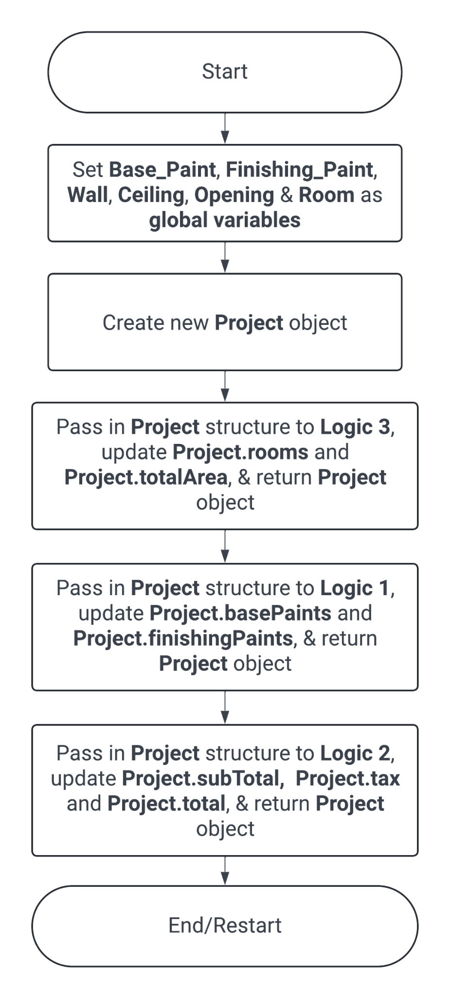

## Logic 1 Flowchart:

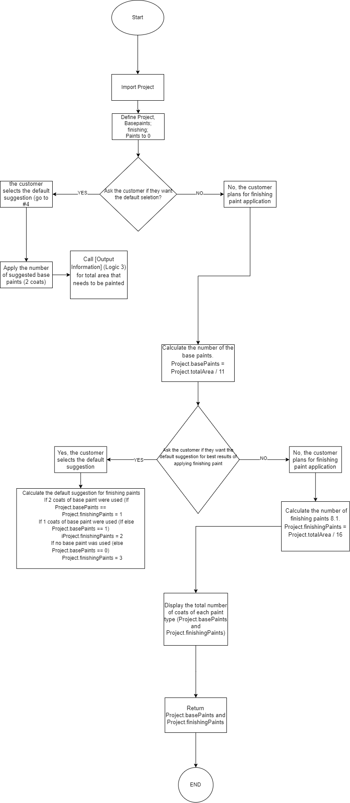

## Logic 2 Flowchart:

## 

## Logic 3 Flowchart:

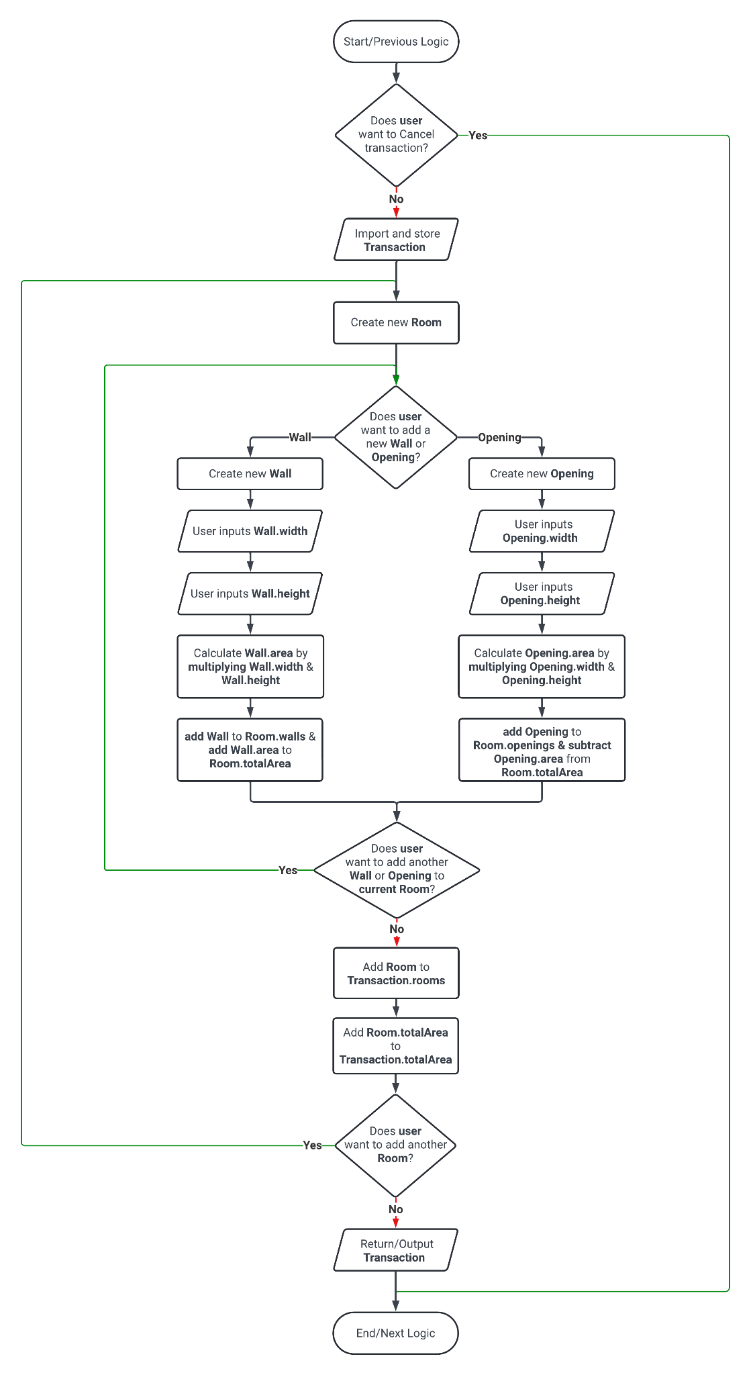

# TEST CASES

Basic Test Case:

Input: Room dimensions: Length = 5m, Width = 4m, Height = 3m

Output:

Total area to be painted: 76m²

Itemized listing:

Base paint:

- Unit cost per can: $46.25

- Number of cans required: 2 (assuming 2 coats)

- Total cost before taxes: $92.50

Finishing paint:

- Unit cost per can: $54.50

- Number of cans required: 5 (assuming 1 coat)

- Total cost before taxes: $272.50

Subtotal before taxes: $365.00

Taxes (HST) amount (13%): $47.45

Total cost including taxes: $412.45

Multiple Rooms Test Case:

Input: Room 1 dimensions: Length = 5m, Width = 4m, Height = 3m

Room 2 dimensions: Length = 3m, Width = 3m, Height = 3m

Output:

Total area to be painted: 61m² (Room 1: 76m², Room 2: 15m²)

Itemized listing:

Base paint:

- Unit cost per can: $46.25

- Number of cans required: 2 (assuming 2 coats)

- Total cost before taxes: $92.50

Finishing paint:

- Unit cost per can: $54.50

- Number of cans required: 4 (assuming 1 coat)

- Total cost before taxes: $218.00

Subtotal before taxes: $310.50

Taxes (HST) amount (13%): $40.37

Total cost including taxes: $350.87

No Base Coat Test Case:

Input: Room dimensions: Length = 6m, Width = 5m, Height = 3m

Output:

Total area to be painted: 90m²

Itemized listing:

Finishing paint:

- Unit cost per can: $54.50

- Number of cans required: 6 (assuming 3 coats)

- Total cost before taxes: $327.00

Subtotal before taxes: $327.00

Taxes (HST) amount (13%): $42.51

Total cost including taxes: $369.51

Custom Coats Test Case:

Input: Room dimensions: Length = 4m, Width = 4m, Height = 3m

Custom coats for base paint: 1

Custom coats for finishing paint: 2

Output:

Total area to be painted: 64m²

Itemized listing:

Base paint:

- Unit cost per can: $46.25

- Number of cans required: 1 (custom coats: 1)

- Total cost before taxes: $46.25

Finishing paint:

- Unit cost per can: $54.50

- Number of cans required: 4 (custom coats: 2)

- Total cost before taxes: $218.00

Subtotal before taxes: $264.25

Taxes (HST) amount (13%): $34.35

Total cost including taxes: $298.60

Ceilings Included Test Case:

Input: Room dimensions: Length = 5m, Width = 4m, Height = 3m

Include ceilings

Output:

Total area to be painted: 104m² (Including ceiling area)

Itemized listing:

Base paint:

- Unit cost per can: $46.25

- Number of cans required: 3 (assuming 2 coats)

- Total cost before taxes: $138.75

Finishing paint:

- Unit cost per can: $54.50

- Number of cans required: 6 (assuming 1 coat)

- Total cost before taxes: $327.00

Subtotal before taxes: $465.75

Taxes (HST) amount (13%): $60.75

Total cost including taxes: $526.50

# FINAL DESCRIPTION

During the workshop, we were assigned to develop an online tool that estimates the amount of paint required for a user's paint project. The tool takes user inputs to determine the total surface area that needs to be covered and recommends the number of paint cans required.

To calculate the area, the application splits the project into rooms containing walls/ceilings or openings. The area of walls/ceilings is added to the room's area, while openings are subtracted from the room's total area. Users can add as many walls or openings to a room and as many rooms to the project as they wish. Finally, Logic 3 outputs the Project data structure, which is then entered into Logic 1.

Logic 1 takes the input and calculates the amount of base paint and finishing paint needed based on the project's total area. After making the calculations, Logic 1 returns the Project data structure, which is inputted into Logic 2.

Logic 2 then uses the information in the Project data structure to generate an itemized list of recommendations, including the types of paint required by the user.